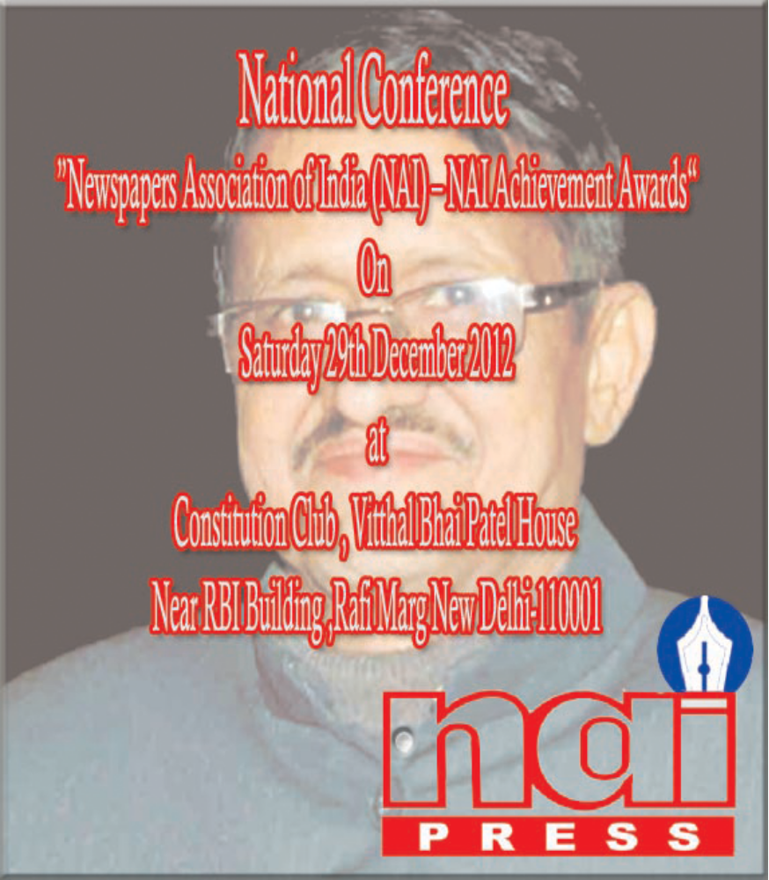
NEWSPAPERS ASSOCIATION OF INDIA (NEW DELHI)
Newspapers Association of India (NAI) represent the press at the grass-root all languages and territories and which constitutes the core of the press in this country since its inception in 1993, has endeavored to bring the Small and A Medium newspapers published from the length and breadth of our great country together under the ambit of one organization. Until now we were successful in bringing together more then 7000 such newspapers and journalist as active members under our association. These newspapers are published in Hindi, English and various vernacular languages. Together they have a reach in every nook and corner of the country. Our association actively takes up matters relating difficulties being faced by the publishers of these newspapers and also disseminates useful information to them from time to time.

The Conference would be focusing on the role that the regional newspapers play in the strengthening of our World’s largest democracy. The emphasis would be on how the regional newspapers of our democratic institutions with adherence to secular credentials. The strength of our democracy lies in the dissemination of information and these regional and vernacular language newspapers with their reach deep in the hinterland can and plays an effective role in the propagation of democratize ideas and advantages of people power.

The objective of NAI is to highlight the problems which have been plaguing the small and medium newspaper industry for the past so many years. A common platform at the national level was created for the members, to establish personal Contact with each other and have interactions on related problems and take up the same, with concerned authorities, on a collective basis.
With its members (Daily, Weekly’s, Bi Weekly’s Fortnightly’s, Monthly’s, Online Digests & others) the NAI is also serving the national cause of having unity in diversity, in as much as our membership. Is spread throughout the length and breadth of the country, with newspapers-both national and regional- printed in diverse vernacular as well as English language being our associates. NAI aims to encourage and support small and medium newspapers, journals, periodicals, etc., to create innovative sustainable social enterprises and aims to build a just, civil society in India.

Theme
“Problem Facing By Small & Medium Newspapers or Journalist”

- Journalist’s problems and solutions.
- Publishers and Editor’s problems and solutions.
- Problem of Journalist in North East, Uttrakhand, Rajasthan, U.P Trouble and Rural areas.
- How to provide good benefits to NAI members and other journalist.
- How to develop Rural and Grassroots Journalism.
- Indian Language Promotion ( Hindi & Urdu).
- Govt. Accreditation for Full time Journalist.
- D.A.V.P , D.I.P Ads for Small & Medium Newspapers and Magazine.
- Social Programs, Cultural Programs in all over India.
- Seminars, Workshop Media Programs to aware Media People or journal People.
- Online News Service for NAI members.
- Medial Help and Complaint Center in all state.
- State Governments have to Provide Press Club in every Disst- for all Type journalists.
Newspapers Association of India
National Annul Conference & NAI Awards 2012
Venue: Constitution Club of India Rafi Marg Vitthal Bhai Patel House
New Delhi - 110001
SCHEDULE OF PROGRAMME

1st Session
The Chief Guest of the Session
Shri Ninong Ering
Hon’ble Union Minister of State , Minority Affairs Govt. Of India

Registration : 03.00PM- 03.30 PM.
INAUGURAL SESSION
03.30PM – 5.30 PM.

Introduction : Newspapers Association of India ,
Central Committee & State Committees
Welcome Address : Sh. Suryabhan Rajput President, NAI
Theme of the Session : Dr. Dilip Kumar, Managing Editor NAI
Speaker : SMT Manoranjana Sinh Editor in Chief Frontier T.V News
Key Note Address : Shri Ninong Ering Hon’ble Minister of State , Minority Affairs GOI
Speech of Hon’ble Chief Guest
Distribution of NAI Awards

2nd Session
The Chief Guest of the Session
Shri Sachin Pilot
Hon’ble Minister of Corporate Affairs Govt. of India

5.30PM – 6.30PM
Welcome Address : Shri Vipin Gaur – General Secretary NAI
Theme and Topic : Shri Sunil Dang - Editor Day After
Speaker : Smt. Sumita Mishra and Dr Khawaja Mohd.Ekramuddin
Key Note Address : Shri Sachin Pilot Hon’ble Minister of Corporate Affairs
Speech of Hon’ble Chief Guest
Distribution of NAI Awards

3nd Session
The Chief Guest of the Session
Shri Harish Rawat
Hon’ble Minister Water Recourses Govt. of India
6.30PM – 8PM
Welcome Address :
Theme and Topic : Shri Sandeep Marwah – Director of AAFT & ASMS
Speaker : Shri Praveen Sahni – Editor - Samachar Plus
Key Note Address : Shri Hrish Rawat – Minister of Water Recourses Govt. of India
Speech of Hon’ble Chief Guest
Distribution of NAI Awards
Special Guest and Speaker of the program

Shri Sunil Dang Shri Sandeep Marwah Dr Khawaja Mohd.Ekramuddin
DayAfter International Director of AAFT,ASMS Director of N.C.P.U.L GOI

Pro. Sumita Mishra Mrs Manoranjana Sinh Dr Sarojni Nandal

NAI Achievements awards 2012
The Special Award in this year - Dr. M.R Gaur Lifetime Achievement Award
Kewal Lakheda and Best NAI State President Shreedhar Reddy

In Electronic Media
Best News Channel : Real News TV
Best News Anchor : Yet to be Finalized
Best News Anchor (Regional) : Ranjan Goswami @ Prag News Assam
Best Correspondent : Mohit Malhotra Correspondent @ News 24
Best Crime Correspondent : Naveen lal Suri, Correspondent @ Sahara Samay
Best Female Correspondent : Tripta Arya, Correspondent @ Sahara Samay
Best Investigative Correspondent : Parimal Kumar, Sr.Correspondent @ NDTV
Best Cameraman : Yet to be Finalized
Best Editor in Chief : Manoranjana Sinh ( Frontier T.V )
Best Producer : Rakesh Prakash @ ZEE T.V
In Print Media
Best Regional Newspaper : Panchyat Ujala ( Uttrakhand )
Best magazine : Yet to be Finalized
Best Editor : Yet to be Finalized
Best Reporter : Yet to be Finalized
Best Column Writer : Jaishree Rathore ( Chandigarh )
Best Photographer : Yet to be Finalized

Other Categories
Best NAI State Committee : Rajasthan State
Best Social Worker ( Child Welfare) : Cpt. Ramkaran Singh Malik
Best Social Worker (Women Welfare) : Priyanka Bisht
Best Social Activist : “Shreedhar Murthy
Best Social Worker (Rural Development) : Ram Kishor Choudhary
Best Social Worker : Sunil Kumar
Best Social NGO : Plant & Animal Voice (Mumbai)
Best Developing Person of the Year : Yet to be Finalized
Eminent Personalities : Jogender Singh (Indian Wrestler)

